***project -1***

* ***create an ec2 instance and connect to git bash terminal.***
* ***Allow the inbound rule of security group with port range 80.As http by default runs on port 80.***

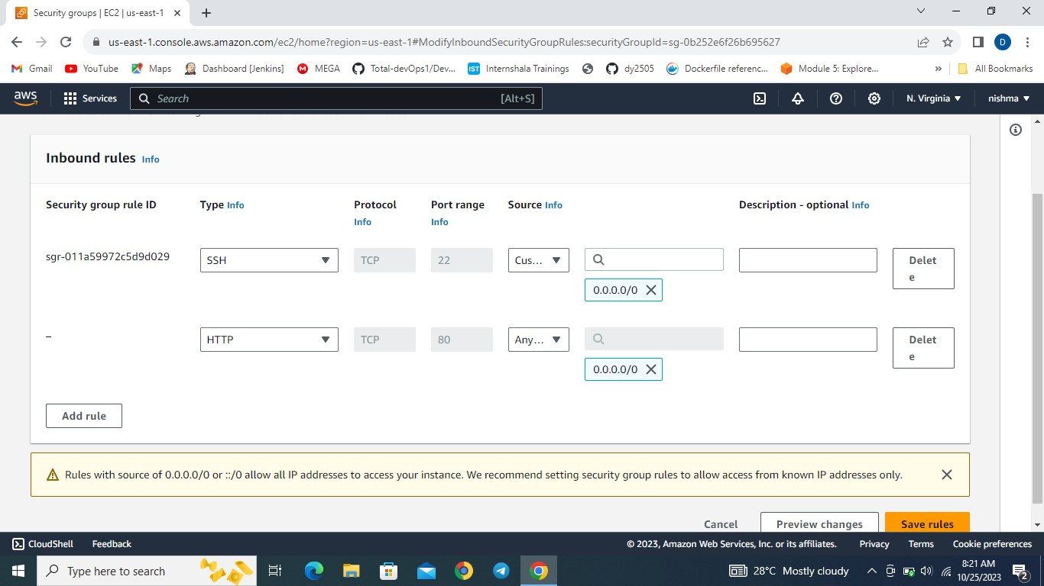

* ***sudo yum install git command to install git.***

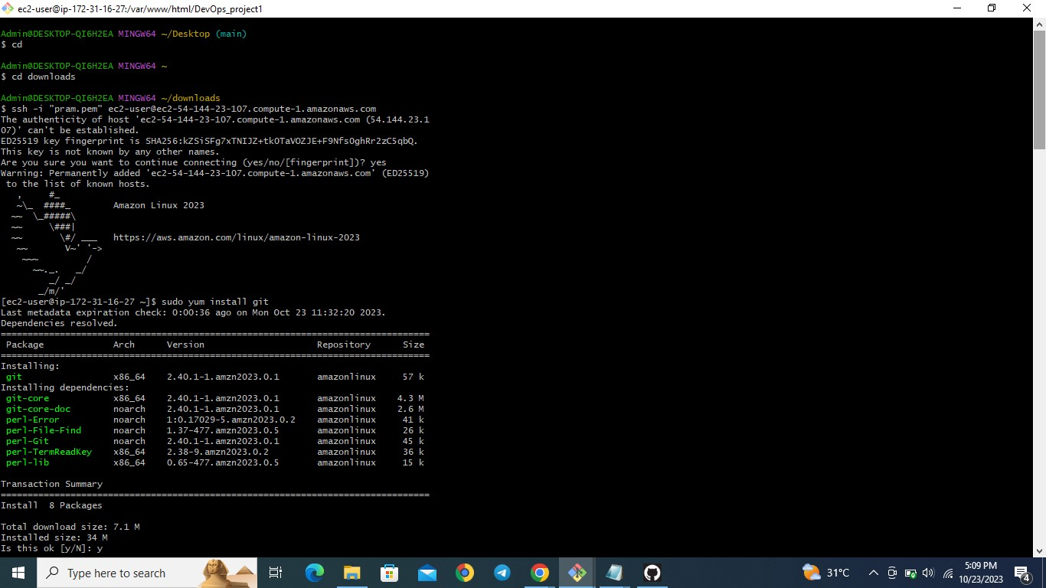

* ***sudo yum install httpd command to install httpd.***
* ***Sudo systemctl start httpd command to start httpd.***
* ***Sudo systemctl enable httpd command to enable httpd.***
* ***Sudo systemctl status httpd command to check if httpd is running or not.***

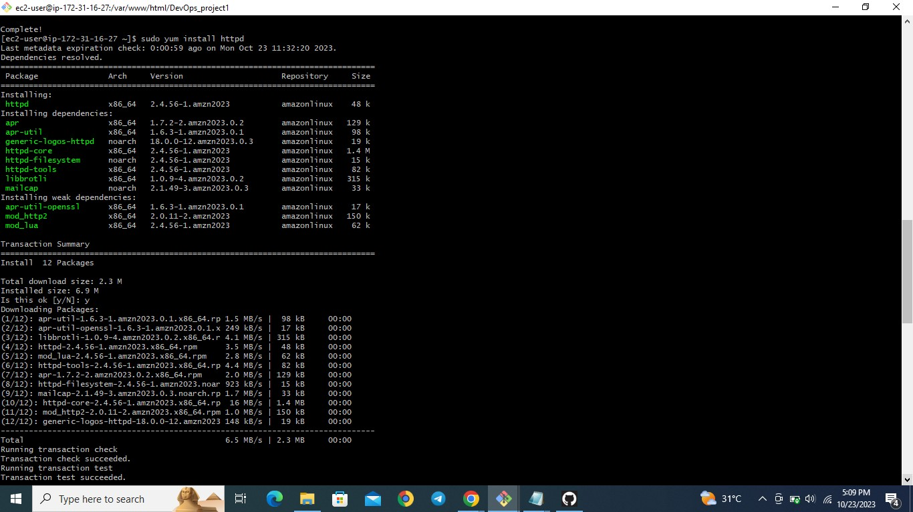

* ***Change the directory to / var/www/html.***
* ***It is the default directory of httpd.***
* ***Sudo git clone <URL> to copy the repository.***
* ***Copying the repository in /var/www/html directory.***
* ***Now copy the public ip address and paste it on the browser.***





* ***Hosted this website on ec2 instance.***